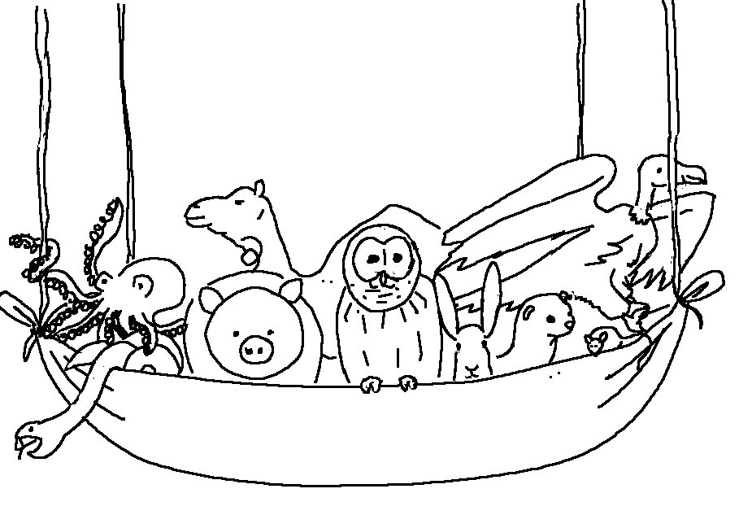
God does not show favoritism
Acts 10:34 _{NIV}

